**DATE: 10-03-22**

**WEBLEM 4**

**Introduction to Validation server – SAVES server**

Homology model, threading method and ab-initio method of tertiary structure prediction all have to be evaluated to make sure that the structural features of the model are consistent with the physicochemical rules. This involves checking anomalies in φ–ψ angles, bond lengths, close contacts, and so on. Another way of checking the quality of a protein model is to implicitly take these stereochemical properties into account. This is a method that detects errors by compiling statistical profiles of spatial features and interaction energy from experimentally determined structures. By comparing the statistical parameters with the constructed model, the method reveals which regions of a sequence appear to be folded normally and which regions do not. If structural irregularities are found, the region is considered to have errors and has to be further refined.

**SAVES server:**

SAVES server contains various tools for structure validation that are all integrated in one single server. The tool available are:

**ERRAT:**

A novel method for differentiating between correctly and incorrectly determined regions of protein structures based on characteristic atomic interaction is described. Different types of atoms are distributed nonrandomly with respect to each other in proteins. Errors in model building lead to more randomized distributions of the different atom types, which can be distinguished from correct distributions by statistical methods. Atoms are classified in one of three categories: carbon (C), nitrogen (N), and oxygen (O). This leads to six different combinations of pairwise noncovalently bonded interactions (CC, CN, CO, NN, NO, and OO). A quadratic error function is used to characterize the set of pairwise interactions from nine-residue sliding windows in a database of 96 reliable protein structures. Regions of candidate protein structures that are mistraced or misregistered can then be identified by analysis of the pattern of nonbonded interactions from each window.

Errat is a program for verifying protein structures determined by crystallography. Error values are plotted as a function of the position of a sliding 9-residue window. The error function is based on the statistics of non- bonded atom-atom interactions in the reported structure (compared to a database of reliable high-resolution structures).

A plot of an initial model and a final model is retrieved. Regions of the structure that can be rejected at the 95% confidence level are yellow; 5% of a good protein structure is expected to have an error value above this level. Regions that can be rejected at the 99% level are shown in red. Generally speaking, the method is sensitive to smaller errors than 3-D Profile analysis.

**Verify3D:**

It is another server using the statistical approach. It uses a precomputed database containing eighteen environmental profiles based on secondary structures and solvent exposure, compiled from high-resolution protein structures. To assess the quality of a protein model, the secondary structure and solvent exposure propensity of each residue are calculated. It determines the compatibility of an atomic model (3D) with its own amino acid sequence (1D) by assigning a structural class based on its location and environment (alpha, beta, loop, polar, nonpolar etc) and comparing the results to good structures. If the parameters of a residue fall within one of the profiles, it receives a high score, otherwise a low score. The result is a two-dimensional graph illustrating the folding quality of each residue of the protein structure. The threshold value is normally set at zero. Residues with scores below zero are considered to have an unfavourable environment.

**PROVES:**

It calculates the volumes of atoms in macromolecules using an algorithm which treats the atoms like hard spheres and calculates a statistical Z-score deviation for the model from highly resolved (2.0 Å or better) and refined (R-factor of 0.2 or better) PDB-deposited structures.

Standard ranges of atomic and residue volumes are computed in 64 highly resolved and well-refined protein crystal structures using the classical Voronoi procedure. Deviations of the atomic volumes from the standard values, evaluated as the volume Z-scores, are used to assess the quality of protein crystal structures. To score a structure globally, we compute the volume Z-score root mean square deviation (Z-score rms), which measures the average magnitude of the volume irregularities in the structure. We find that the Z-score rms decreases as the resolution and R-factor improve, consistent with the fact that these improvements generally reflect more accurate models. From the Z-score rms distribution in structures with a given resolution or R- factor, we determine the normal limits in Z-score rms values for structures solved at that resolution or R- factor. Structures whose Z-score rms exceeds these limits are considered as outliers. Such structures also exhibit unusual stereochemistry, as revealed by other analyses. Absolute Z-scores of individual atoms are used to identify problems in specific regions within a protein model. These Z-scores correlate fairly well with the atomic B-factors, and atoms having absolute Z-scores > 3, occur at or near regions in the model where programs such as PROCHECK identify unusual stereochemistry. Atomic volumes, themselves not directly restrained in crystallographic refinement, can thus provide an independent, rather sensitive, measure of the quality of a protein structure.

**WHAT_CHECK:**

Derived from a subset of protein verification tools from the WHAT IF program, this does extensive checking of many sterochemical parameters of the residues in the model. WHAT IF is a comprehensive protein analysis server that validates a protein model for chemical correctness. It has many functions, including checking of planarity, collisions with symmetry axes (close contacts), proline puckering, anomalous bond angles, and bond lengths. It also allows the generation of Ramachandran plots as an assessment of the quality of the model.

**PROCHECK:**

It is a UNIX program that is able to check general physicochemical parameters such as φ–ψ angles, chirality, bond lengths, bond angles, and so on. It checks the stereochemical quality of a protein structure by analyzing residue-by-residue geometry and overall structure geometry. The parameters of the model are used to compare with those compiled from well-defined, high-resolution structures. If the program detects unusual features, it highlights the regions that should be checked or refined further.

**CRYST:**

This program searches the Protein Data Bank for entries that have a unit cell similar to your input file. CRYST1 record required. Use the standalone CRYST server for more options.

The assessment results can be different using different verification programs. Because no single method is clearly superior to any other, a good strategy is to use multiple verification methods and identify the consensus between them. It is also important to keep in mind that the evaluation tests performed by these programs only check the stereochemical correctness, regardless of the accuracy of the model, which may or may not have any biological meaning. Thus, SAVES server is an excellent platform that provides various validation methods to accurately validate the structures.

**REFERENCES:**

1. SAVESv6.0 - Structure Validation Server. (n.d.-b). Saves.mbi.ucla.edu. Retrieved March 8, 2022, from <https://saves.mbi.ucla.edu/>
2. ERRAT – UCLA-DOE Institute. (n.d.). Retrieved March 8, 2022, from <https://www.doembi.ucla.edu/errat/>
3. Chris Colovos; Todd O. Yeates (1993). Verification of protein structures: Patterns of nonbonded atomic interactions. , 2(9), 1511–1519. doi:10.1002/pro.5560020916
4. Xiong, J. (2008).Tertiary structure prediction. Essential bioinformatics. Cambridge: Cambridge University Press. 220-222.
5. Joan Pontius; Jean Richelle; Shoshana J. Wodak (1996). Deviations from Standard Atomic Volumes as a Quality Measure for Protein Crystal Structures. , 264(1), 0–136. doi:10.1006/jmbi.1996.0628

**DATE: 10-03-22**

**WEBLEM 4a**

**SAVES server**

**(URL:** [**https://saves.mbi.ucla.edu/**](https://saves.mbi.ucla.edu/)**)**

**AIM:**

To validate structure qseq.B99990005 generated from modeller.

**Introduction:**

qseq.B99990005 is the structure predicted using homology modelling using modeller. The structure has to be evaluated to make sure that the structural features of the model are consistent with the physicochemical rules. This can be done using SAVES server.

SAVES is a structure validation server that has various tools like Errat, Verify3D, Prove, Whatcheck, Procheck.and Cryst integrated in one single platform. This involves checking anomalies in φ–ψ angles, bond lengths, close contacts, and so on. Another way of checking the quality of a protein model is to implicitly take these stereochemical properties into account. This is a method that detects errors by compiling statistical profiles of spatial features and interaction energy from experimentally determined structures. By comparing the statistical parameters with the constructed model, the method reveals which regions of a sequence appear to be folded normally and which regions do not. If structural irregularities are found, the region is considered to have errors and has to be further refined.

**METHODOLOGY:**

1. Open homepage for SAVES server. (URL: <https://saves.mbi.ucla.edu/>)
2. Upload structure retrieved from Modeller in PDB format.
3. Obtain results for Errat, Verify3D, Prove, Whatcheck and Procheck.
4. Observe and interpret the results.

**OBSERVATION:**

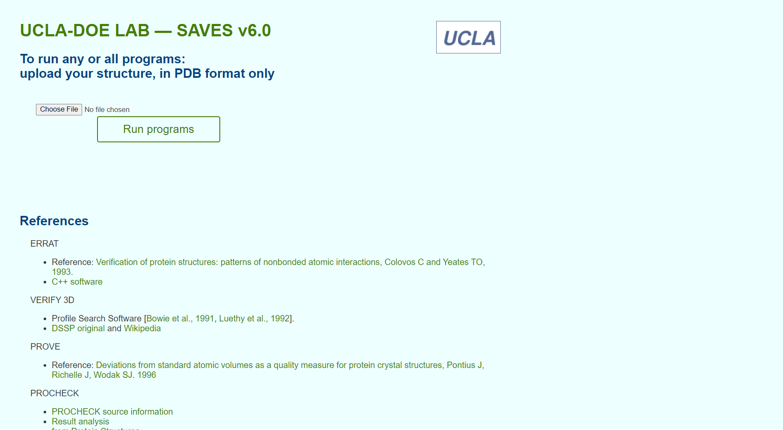**Fig1. Homepage for SAVES server**

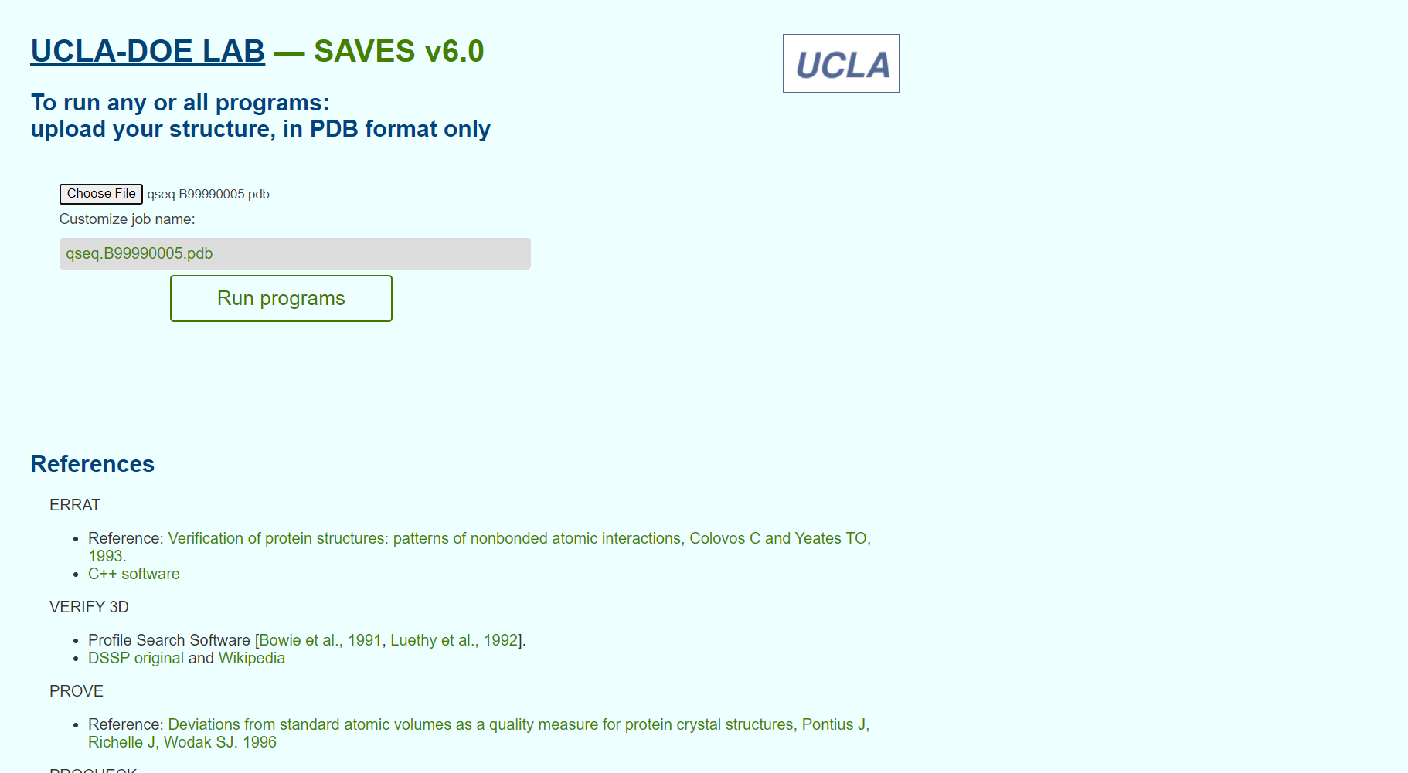**Fig2. Structure from Modeller for validation**

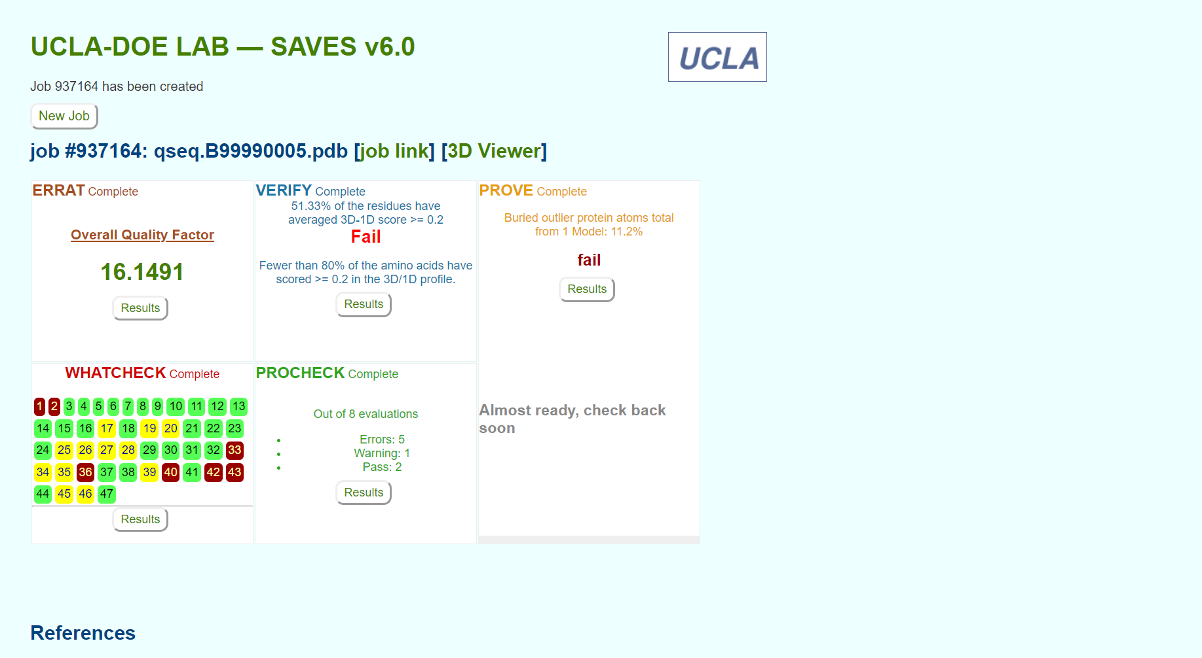**Fig3. Result page for structure validation for various servers**

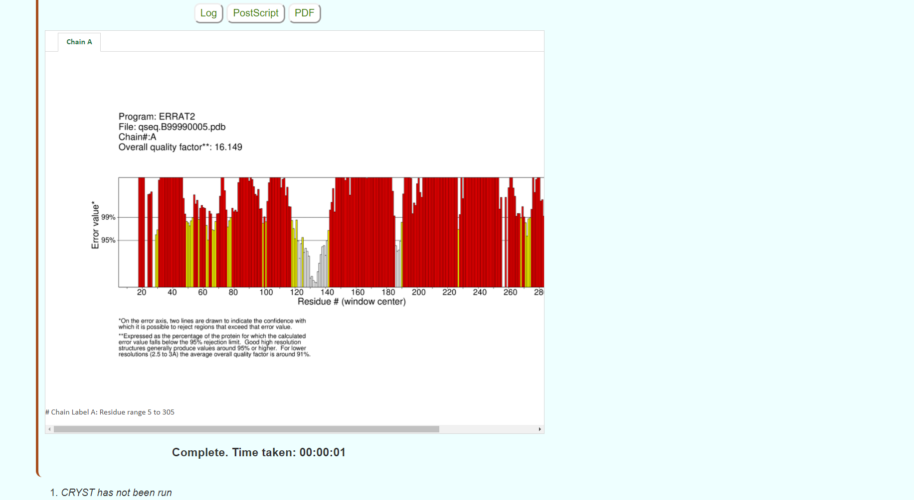**Fig4. Result page for ERRAT**

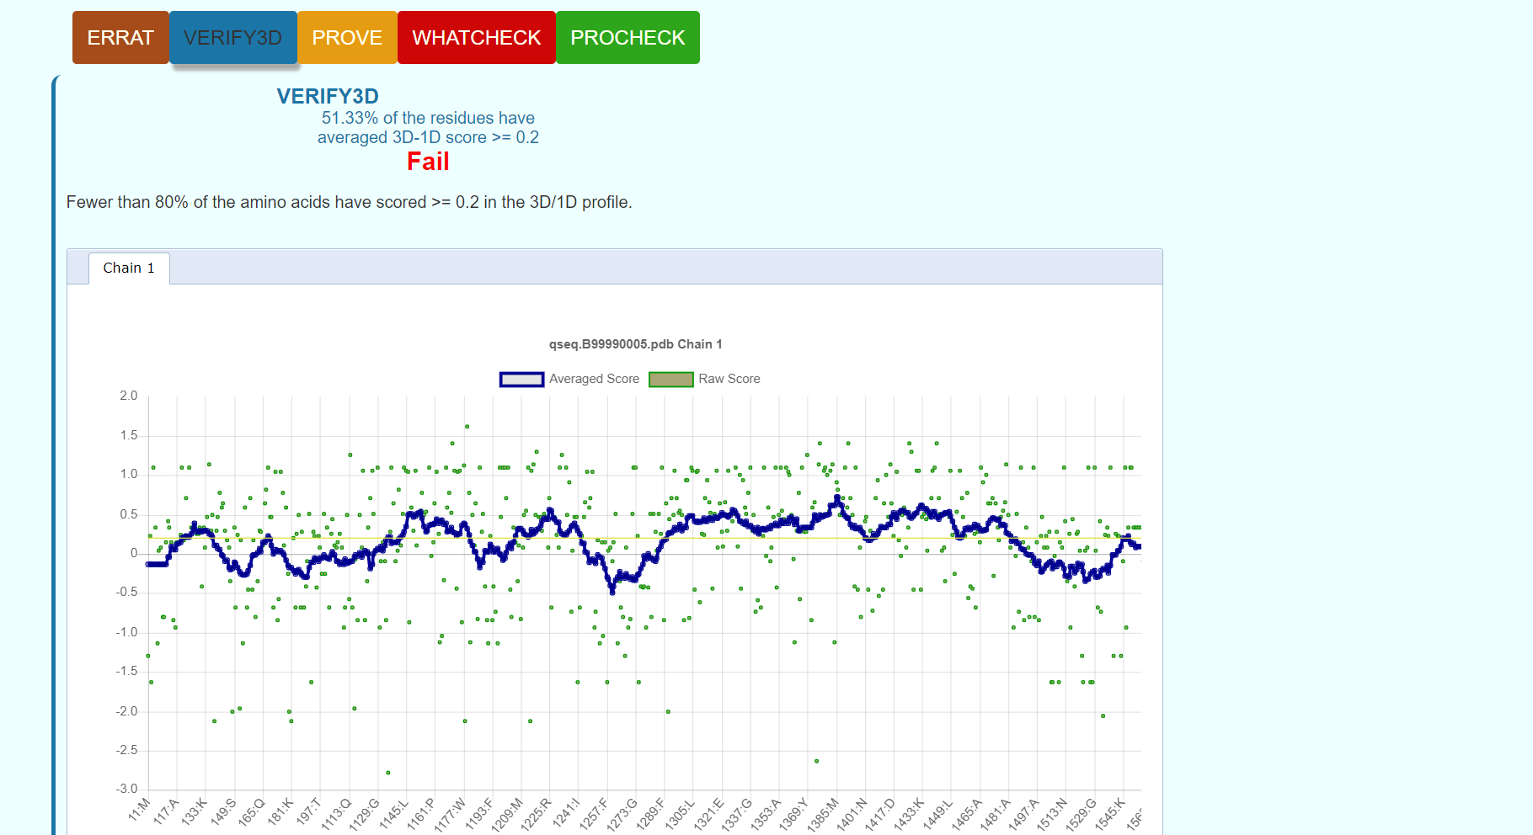**Fig5. Result page for Verify3D**

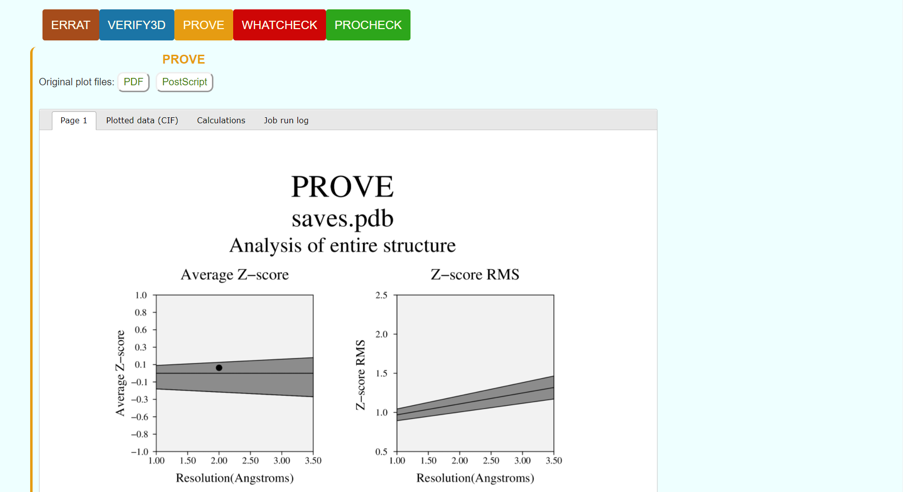**Fig6. Result page for Prove**

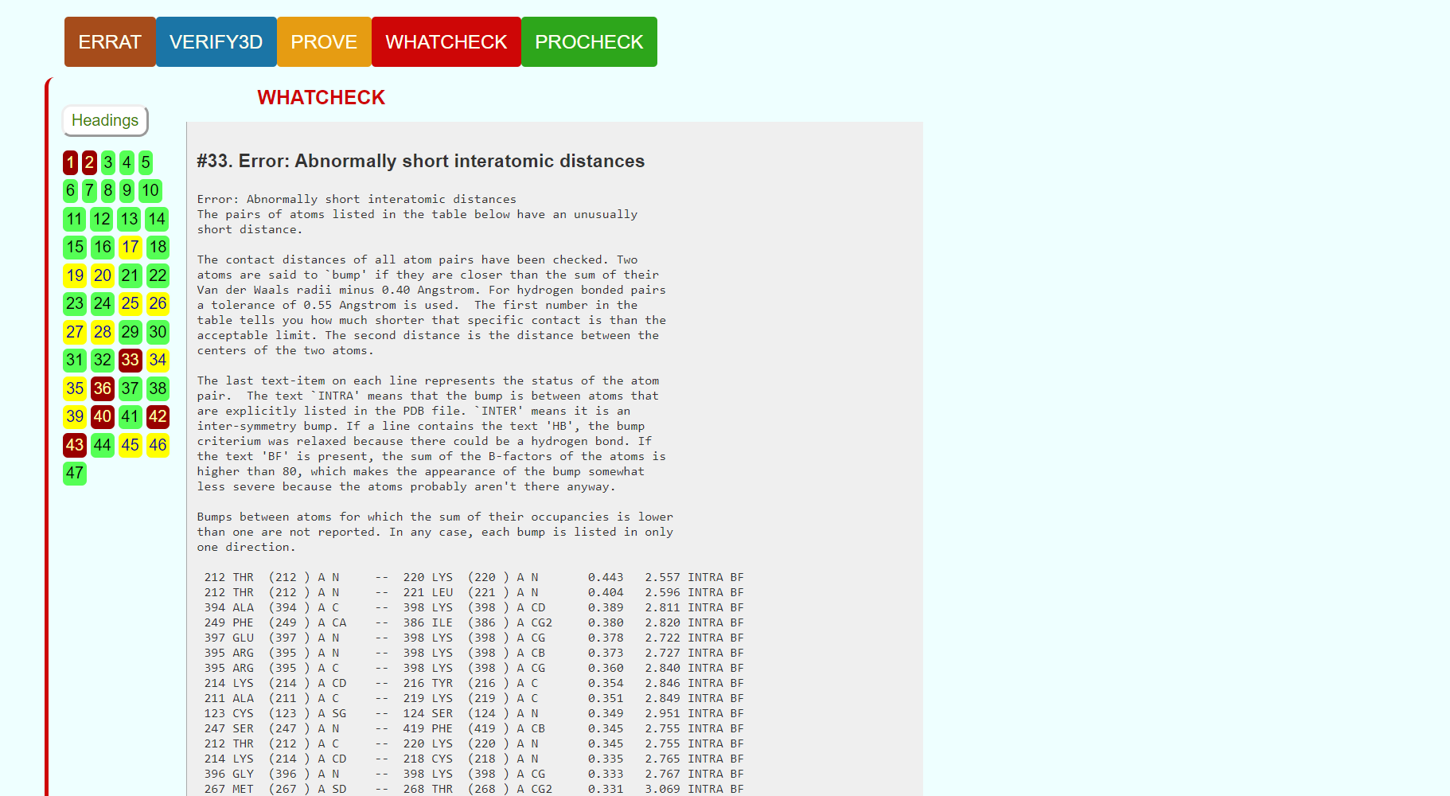**Fig7. Result page for Whatcheck**

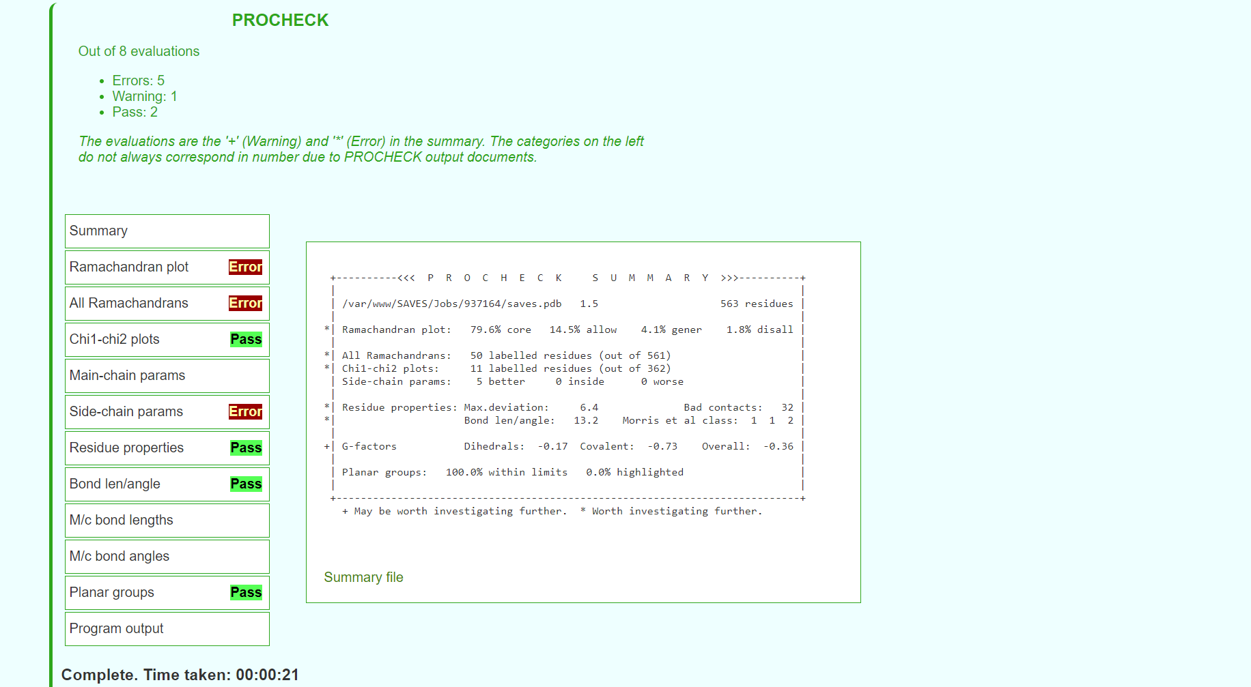**Fig8. Result page for procheck**

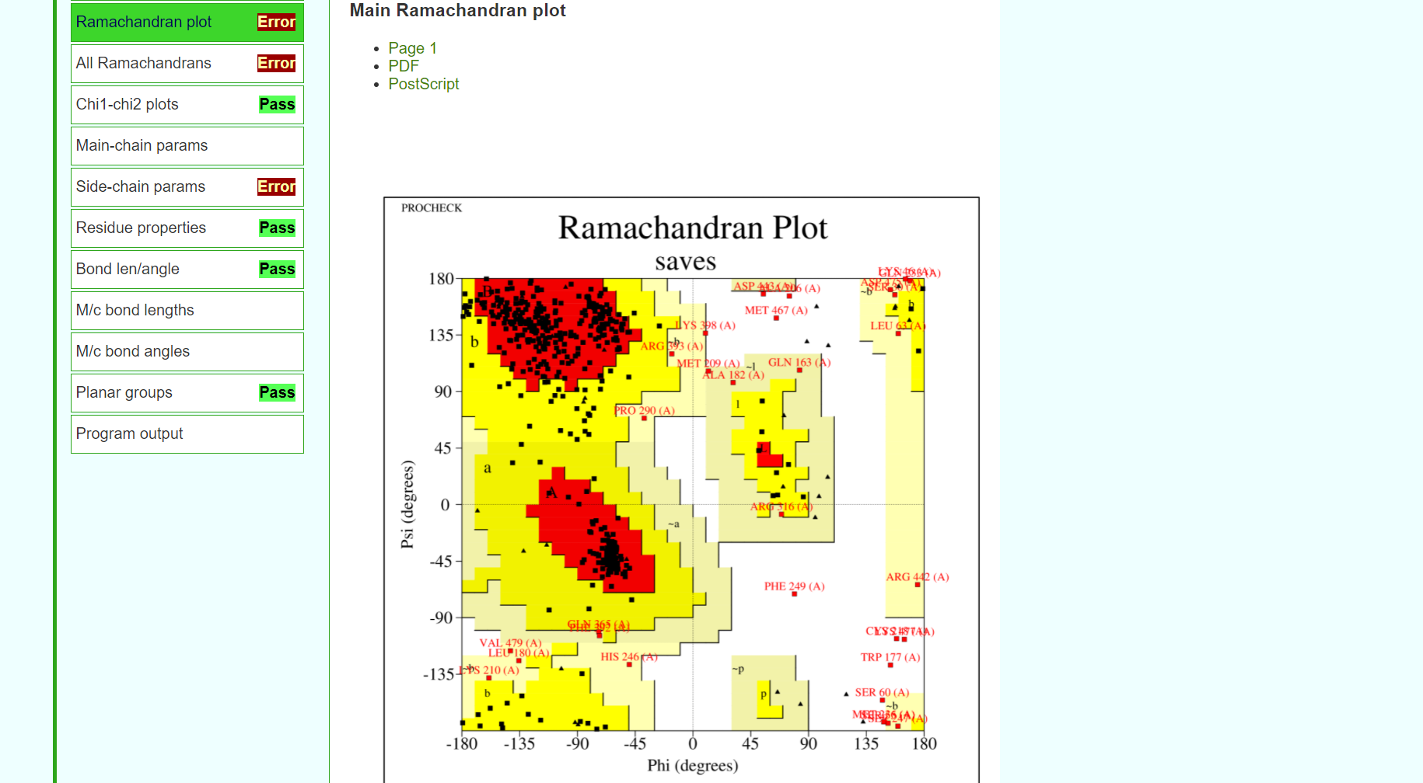**Fig9. Result page for Ramachandran plot**

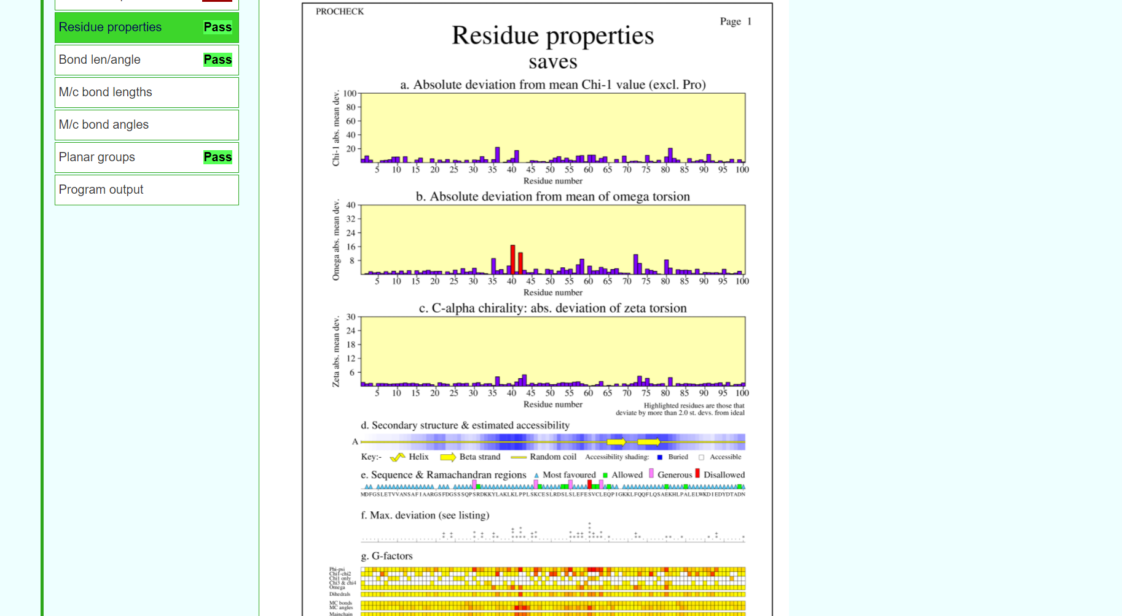**Fig10. Result page for residue properties**

**RESULT:**

The structure predicted for enzyme kinase by homology modelling using modeller was validated using SAVES server.

**CONCLUSION:**

SAVES in an integrated server containing various tools on a single platform that can be used for tertiary structure validation. The predicted structure for rhodopsin by modeller failed the validation thus, I-TASSER based on threading approach will be used to predict a better structure and will be validated again using SAVES server.

**REFERENCES:**

1. Xiong, J. (2008).Tertiary structure prediction. Essential bioinformatics. Cambridge: Cambridge University Press. 220-222.
2. SAVESv6.0 - Structure Validation Server. (n.d.). Saves.mbi.ucla.edu. Retrieved March 8, 2022, from <https://saves.mbi.ucla.edu/>
3. SAVESv6.0 - Structure Validation Server. (n.d.). Saves.mbi.ucla.edu. Retrieved March 8, 2022, from <https://saves.mbi.ucla.edu/?job=924086>

**DATE: 10-03-22**

**WEBLEM 4b**

**SAVES server**

**(**[**URL:https://saves.mbi.ucla.edu/**](URL:https://saves.mbi.ucla.edu/)**)**

**AIM:**

To validate structure model1 generated from I-TASSER server.

**INTRODUCTION:**Model1 is the structure predicted using threading approach using I-TASSER. The structure has to be evaluated to make sure that the structural features of the model are consistent with the physicochemical rules. This can be done using SAVES server.

SAVES is a structure validation server that has various tools like Errat, Verify3D, Prove, Whatcheck, Procheck.and Cryst integrated in one single platform. This involves checking anomalies in φ–ψ angles, bond lengths, close contacts, and so on. Another way of checking the quality of a protein model is to implicitly take these stereochemical properties into account. This is a method that detects errors by compiling statistical profiles of spatial features and interaction energy from experimentally determined structures. By comparing the statistical parameters with the constructed model, the method reveals which regions of a sequence appear to be folded normally and which regions do not. If structural irregularities are found, the region is considered to have errors and has to be further refined.

**METHODOLOGY:**

1. Open homepage for SAVES server. (URL: <https://saves.mbi.ucla.edu/>)
2. Upload structure retrieved from I-TASSER in PDB format.
3. Obtain results for Errat, Verify3D, Prove, Whatcheck and Procheck.
4. Observe and interpret the results.

**OBERSERVATION:**

**Fig1. Homepage for SAVES server**

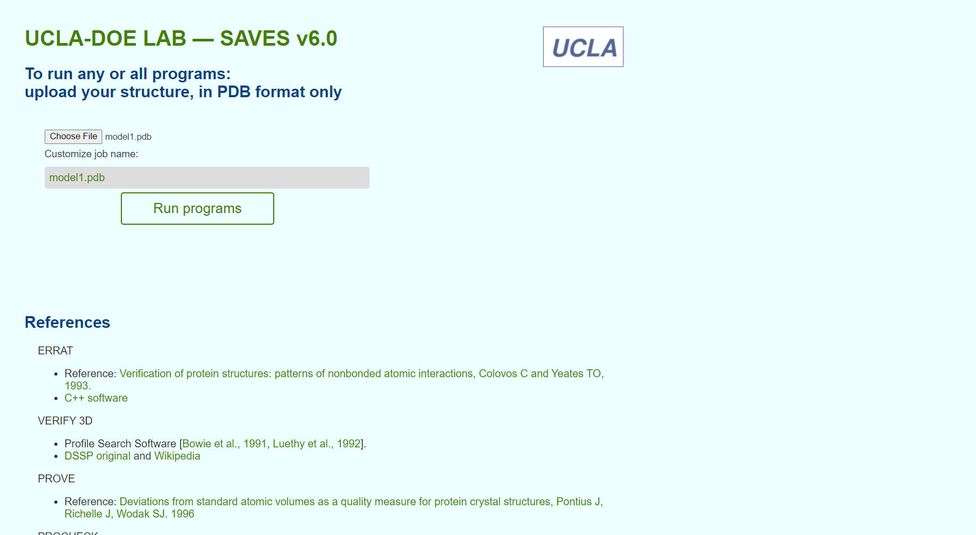**Fig2. Structure from Modeller for validation**

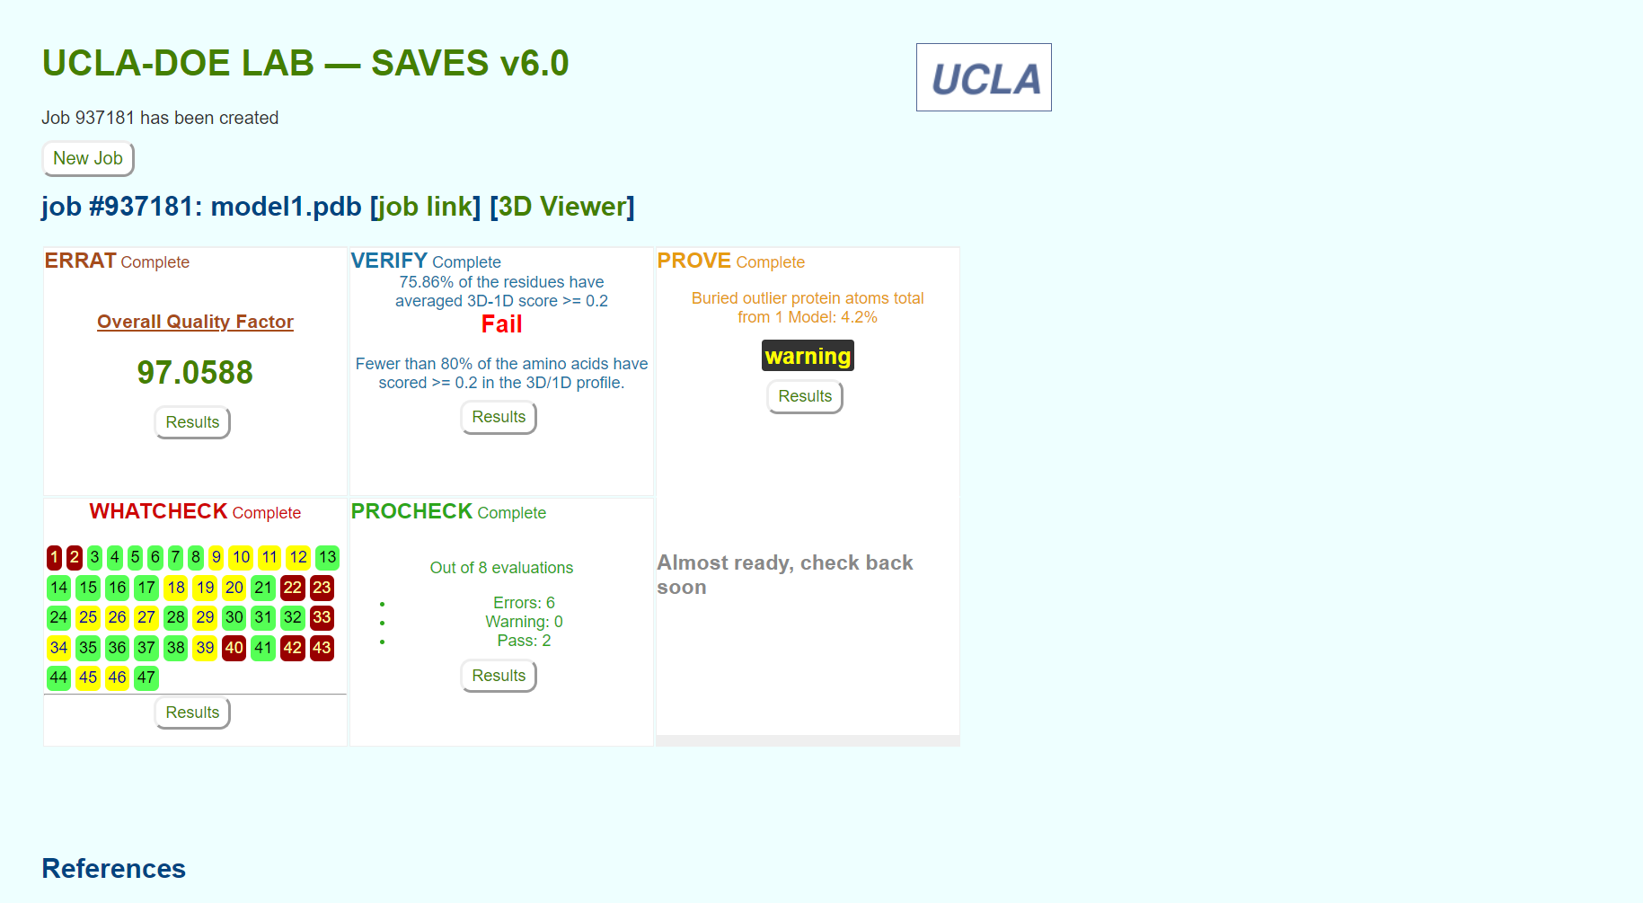**Fig3. Result page for structure validation for various servers**

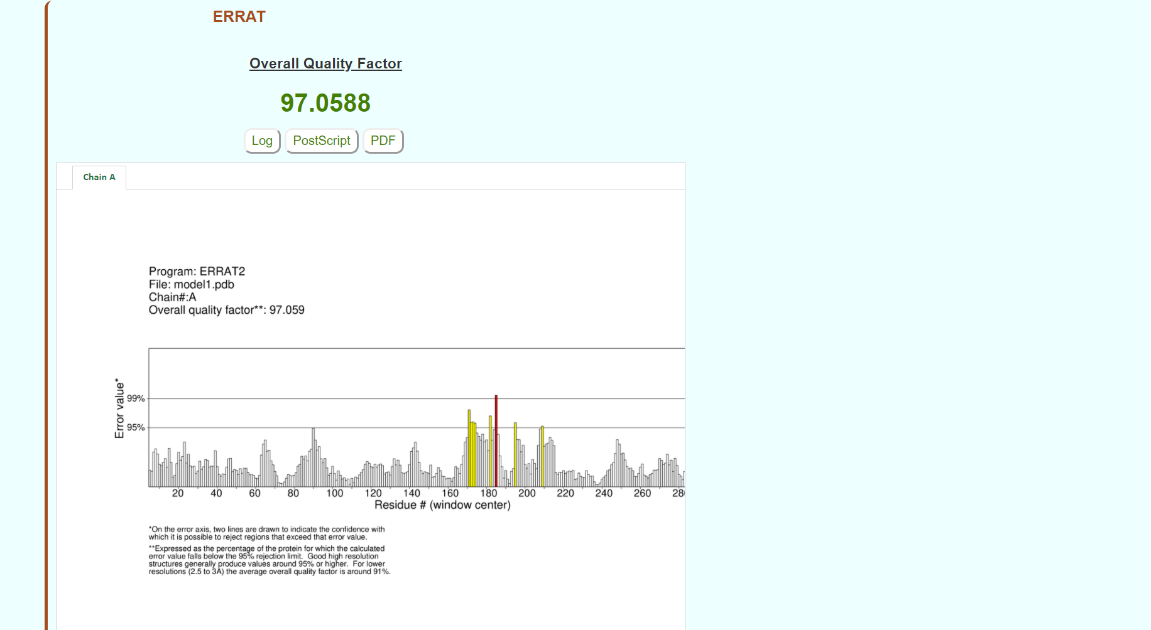**Fig4. Result page for Errat**

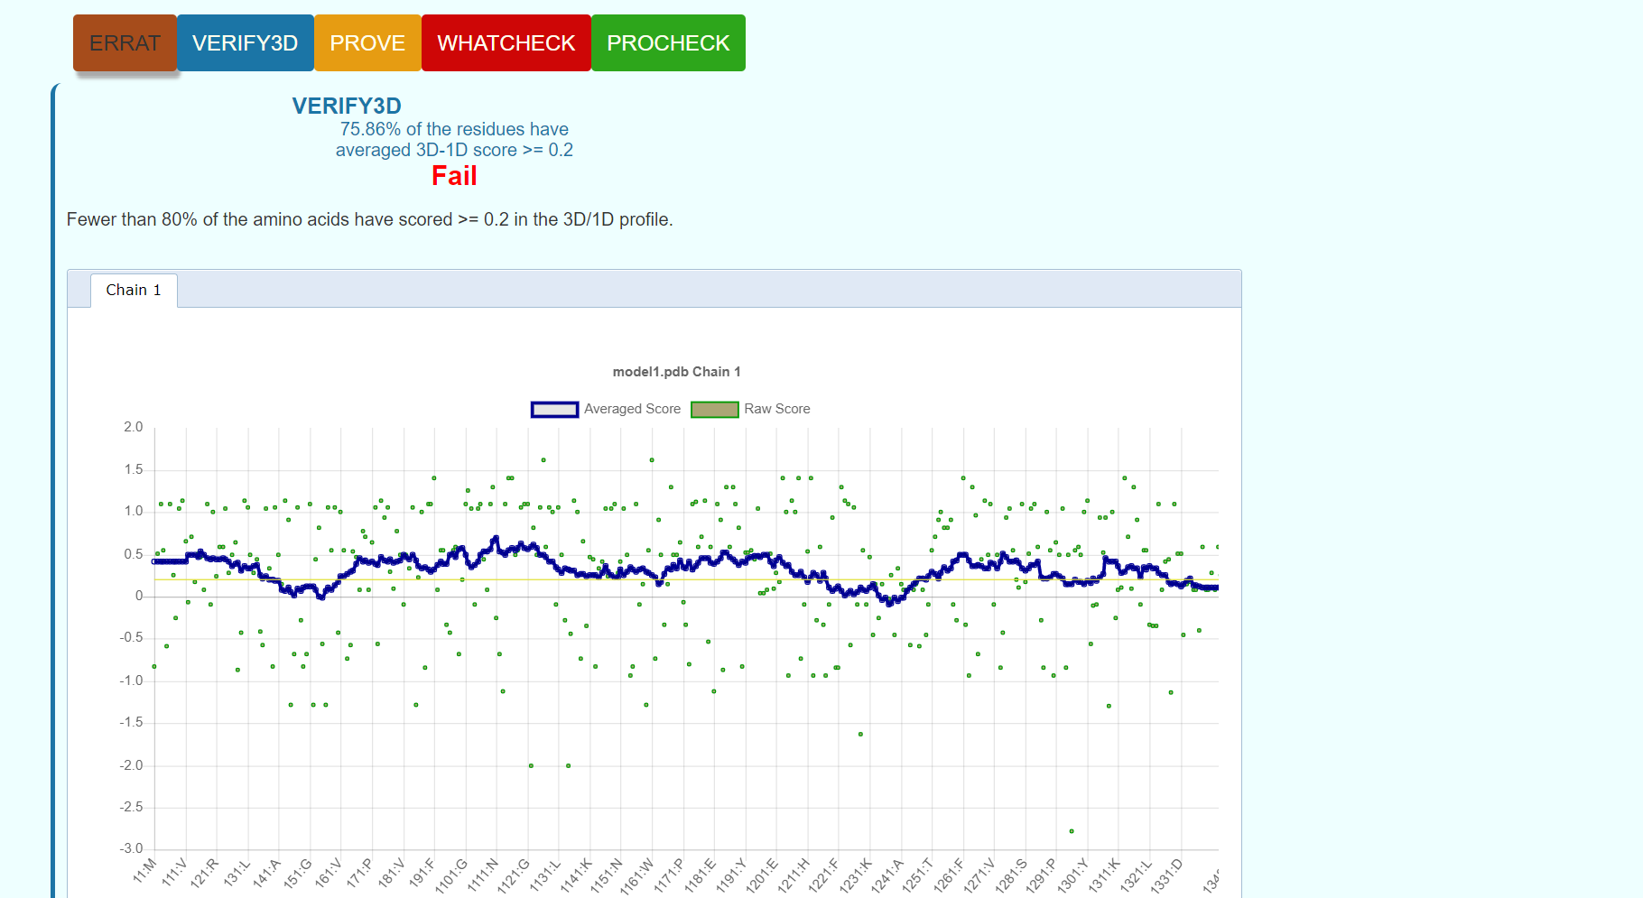**Fig5. Result page for Verify3D**

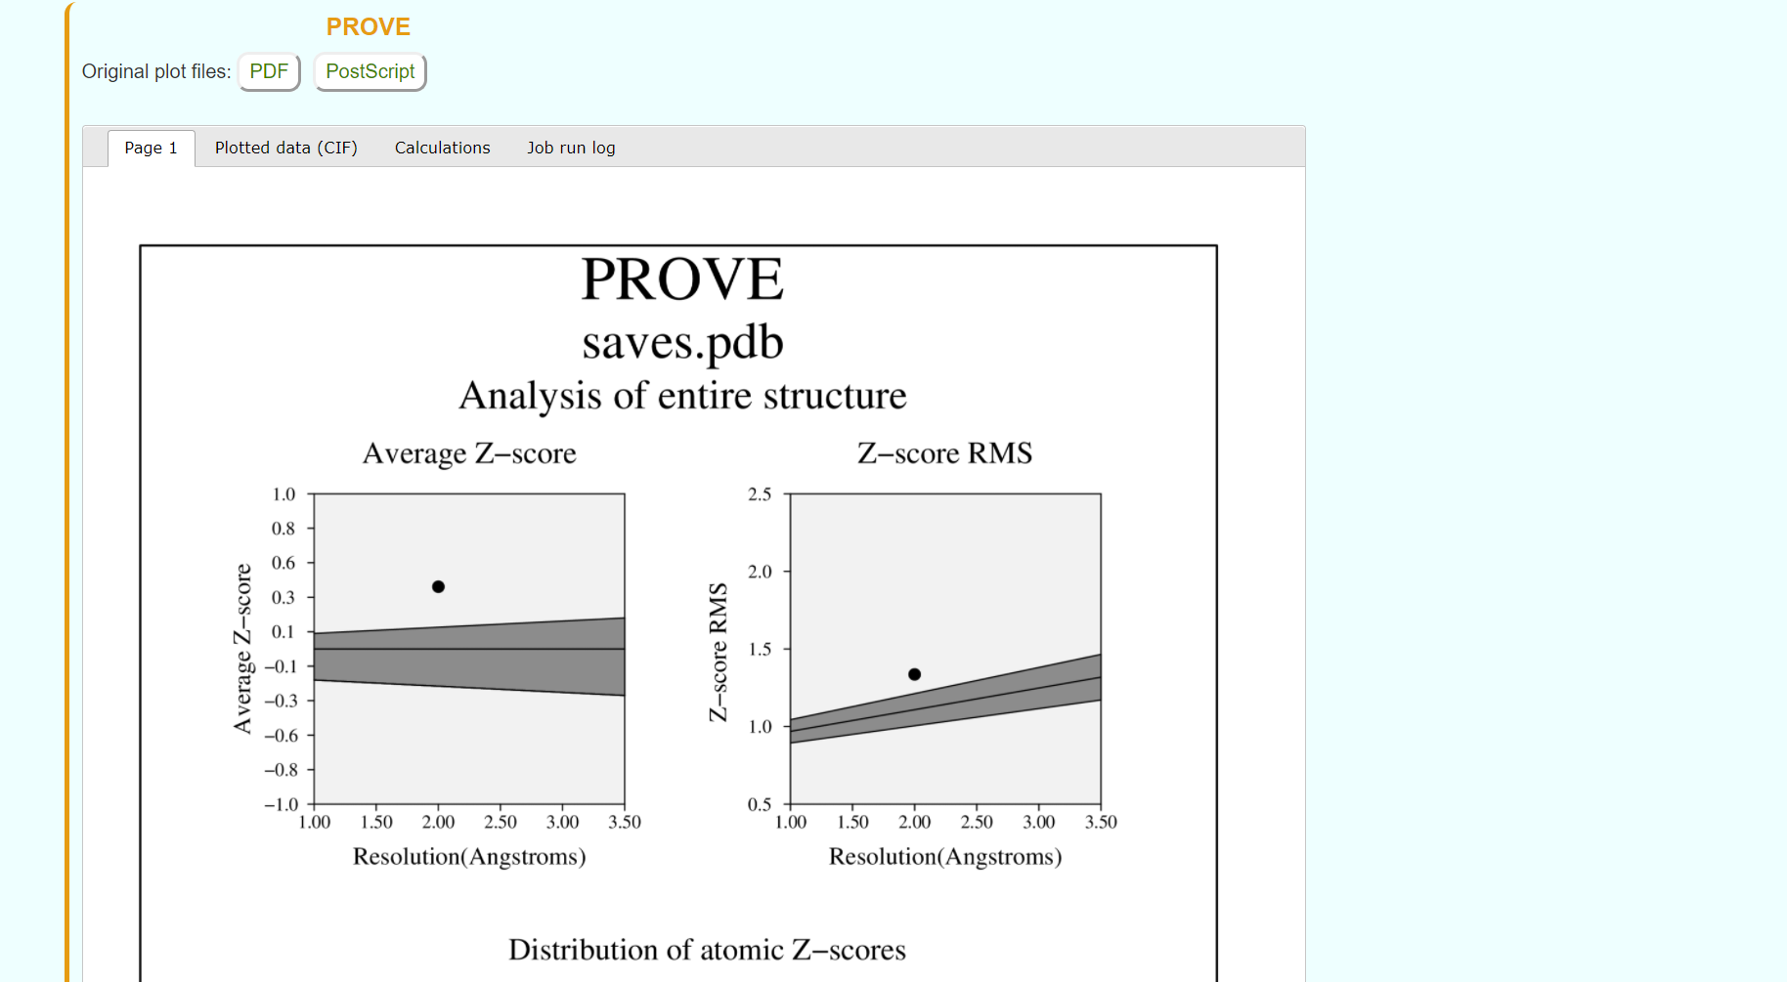**Fig6. Result page for Prove**

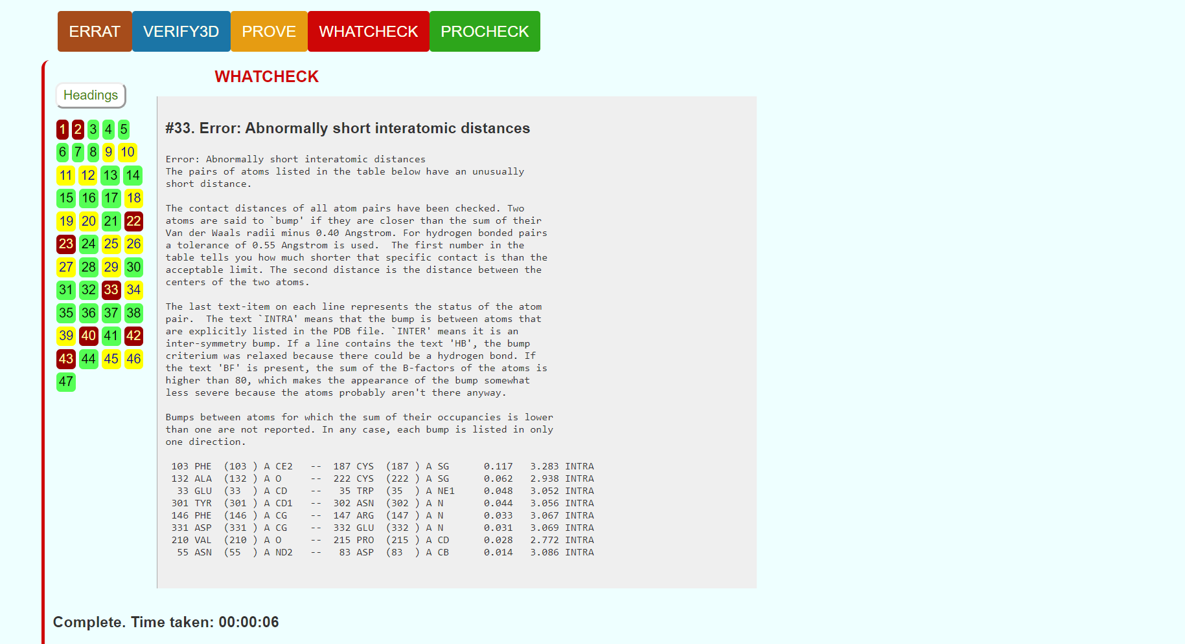**Fig7. Result page for Whatcheck**

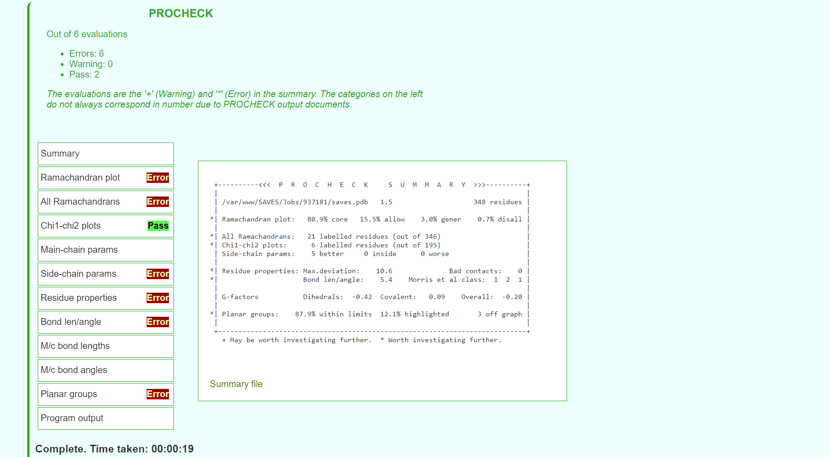**Fig8. Result page for Procheck**

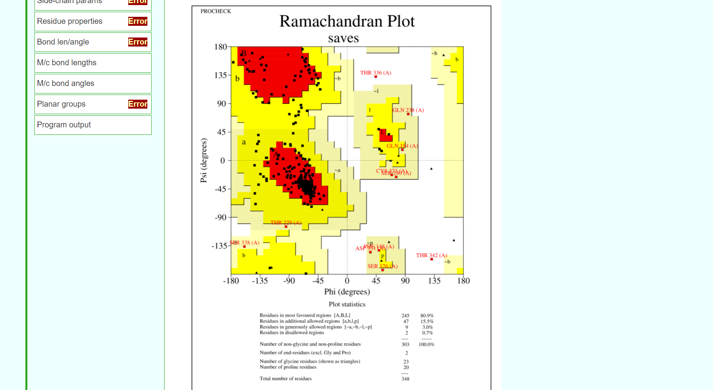**Fig9. Result page for Ramachandran plot**

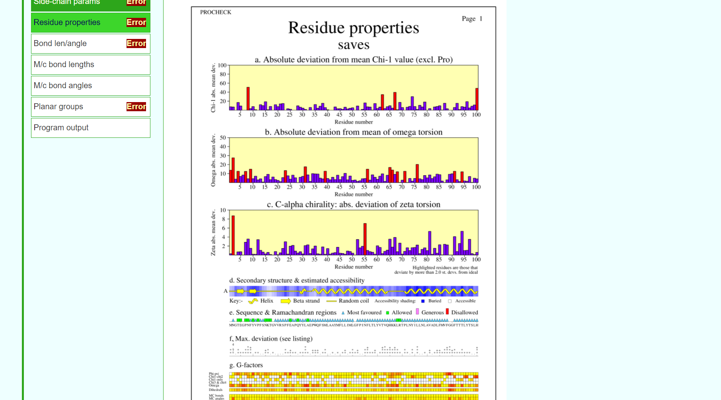**Fig10. Result page for reside properties**

**RESULT:**

The structure predicted for enzyme kinase by threading approach using I-TASSER was validated using SAVES server.

**CONCLUSION:**

SAVES in an integrated server containing various tools on a single platform that can be used for tertiary structure validation. The predicted structure for kinase by I-TASSER passed only for ERRAT and did not give required results for the rest. Even though I-TASSER gave better predicted structure than modeller, Robetta based on ab-initio approach will be used to predict a better structure and will be validated again using SAVES server.

**REFERENCES:**

1. Xiong, J. (2008).Tertiary structure prediction. Essential bioinformatics. Cambridge: Cambridge University Press. 220-222.
2. SAVESv6.0 - Structure Validation Server. (n.d.). Saves.mbi.ucla.edu. Retrieved March 8, 2022, from <https://saves.mbi.ucla.edu/>
3. SAVESv6.0 - Structure Validation Server. (n.d.). Saves.mbi.ucla.edu. Retrieved March 8, 2022, from <https://saves.mbi.ucla.edu/?job=924117>

**DATE: 10-03-22**

**WEBLEM 4c**

**SAVES server**

**(URL:** [**https://saves.mbi.ucla.edu/**](https://saves.mbi.ucla.edu/)**)**

**AIM:**

To validate structure 240040 generated from Robetta server.

**INTRODUCTION:**

240040 is the structure predicted using Ab-initio approach using Robetta. The structure has to be evaluated to make sure that the structural features of the model are consistent with the physicochemical rules. This can be done using SAVES server.

SAVES is a structure validation server that has various tools like Errat, Verify3D, Prove, Whatcheck, Procheck.and Cryst integrated in one single platform. This involves checking anomalies in φ–ψ angles, bond lengths, close contacts, and so on. Another way of checking the quality of a protein model is to implicitly take these stereochemical properties into account. This is a method that detects errors by compiling statistical profiles of spatial features and interaction energy from experimentally determined structures. By comparing the statistical parameters with the constructed model, the method reveals which regions of a sequence appear to be folded normally and which regions do not. If structural irregularities are found, the region is considered to have errors and has to be further refined.

**METHODOLOGY:**

1. Open homepage for SAVES server. (URL: <https://saves.mbi.ucla.edu/>)
2. Upload structure retrieved from Robetta in PDB format.
3. Obtain results for Errat, Verify3D, Prove, Whatcheck and Procheck.
4. Observe and interpret the results.

**OBSERVATION:**

**Fig1. Homepage for SAVES server**

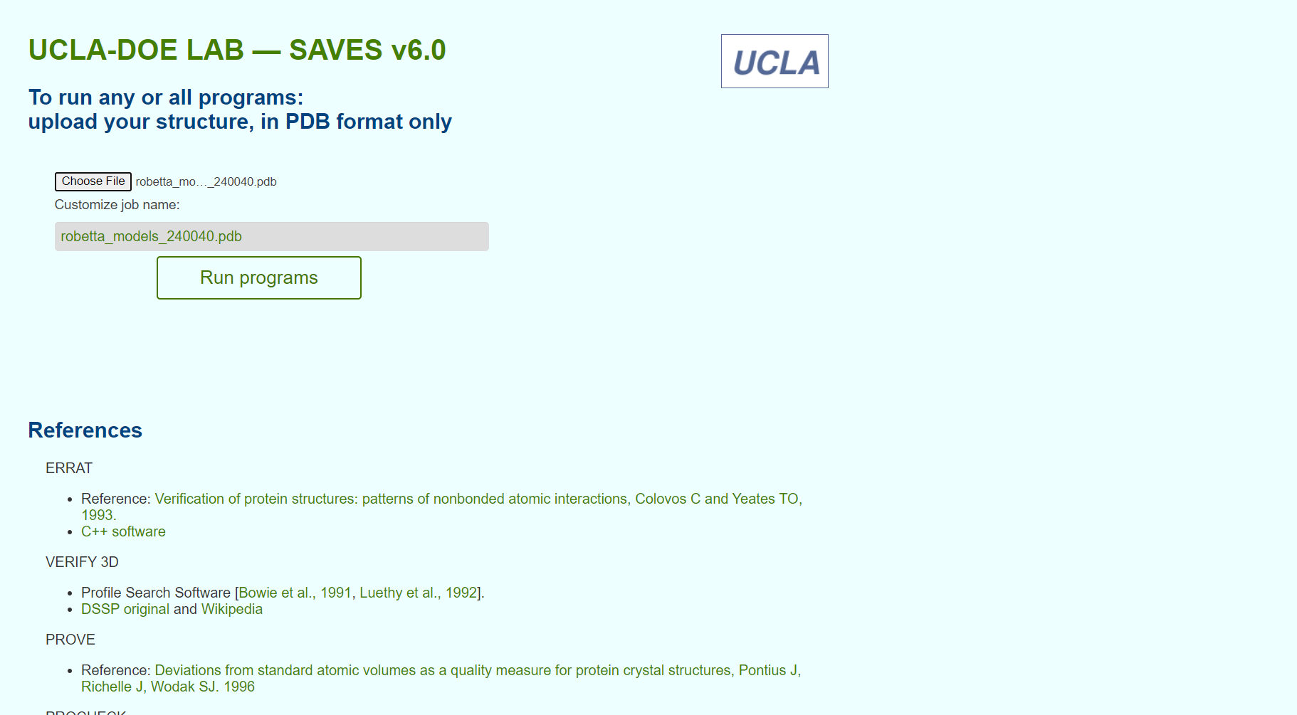**Fig2. Structure from Modeller for validation**

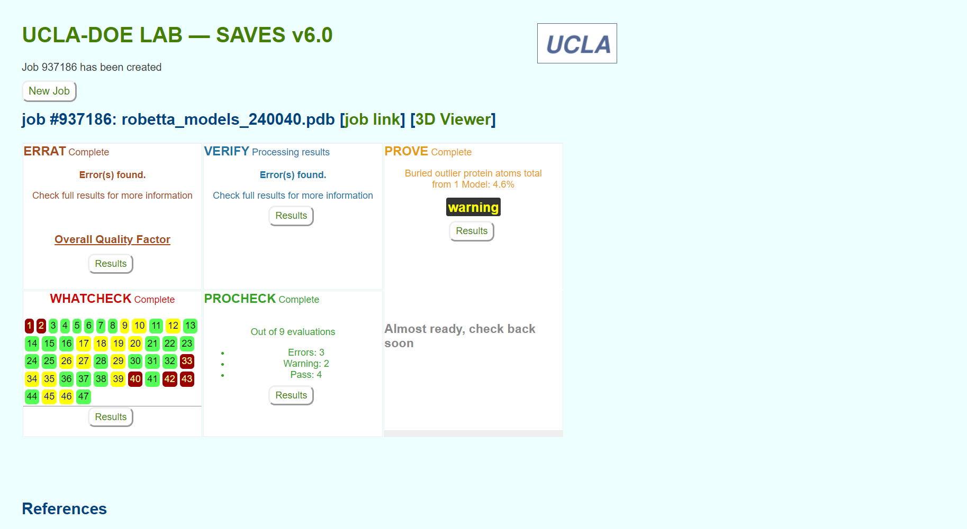**Fig3. Result page for structure validation for various servers**

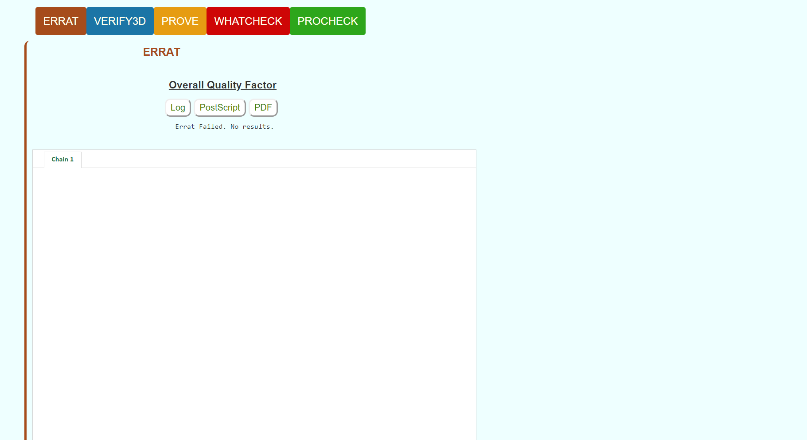**Fig4. Result page for Errat**

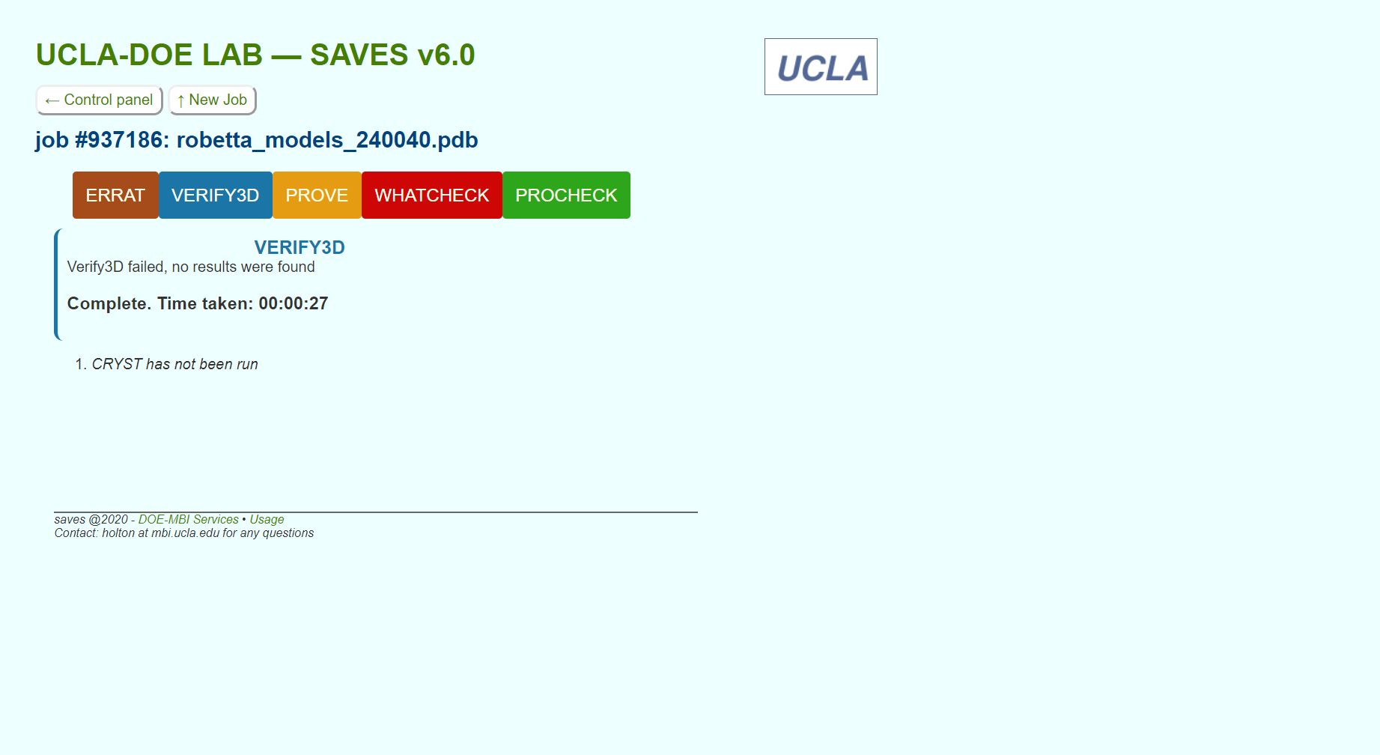**Fig5. Result page for Verify3D**

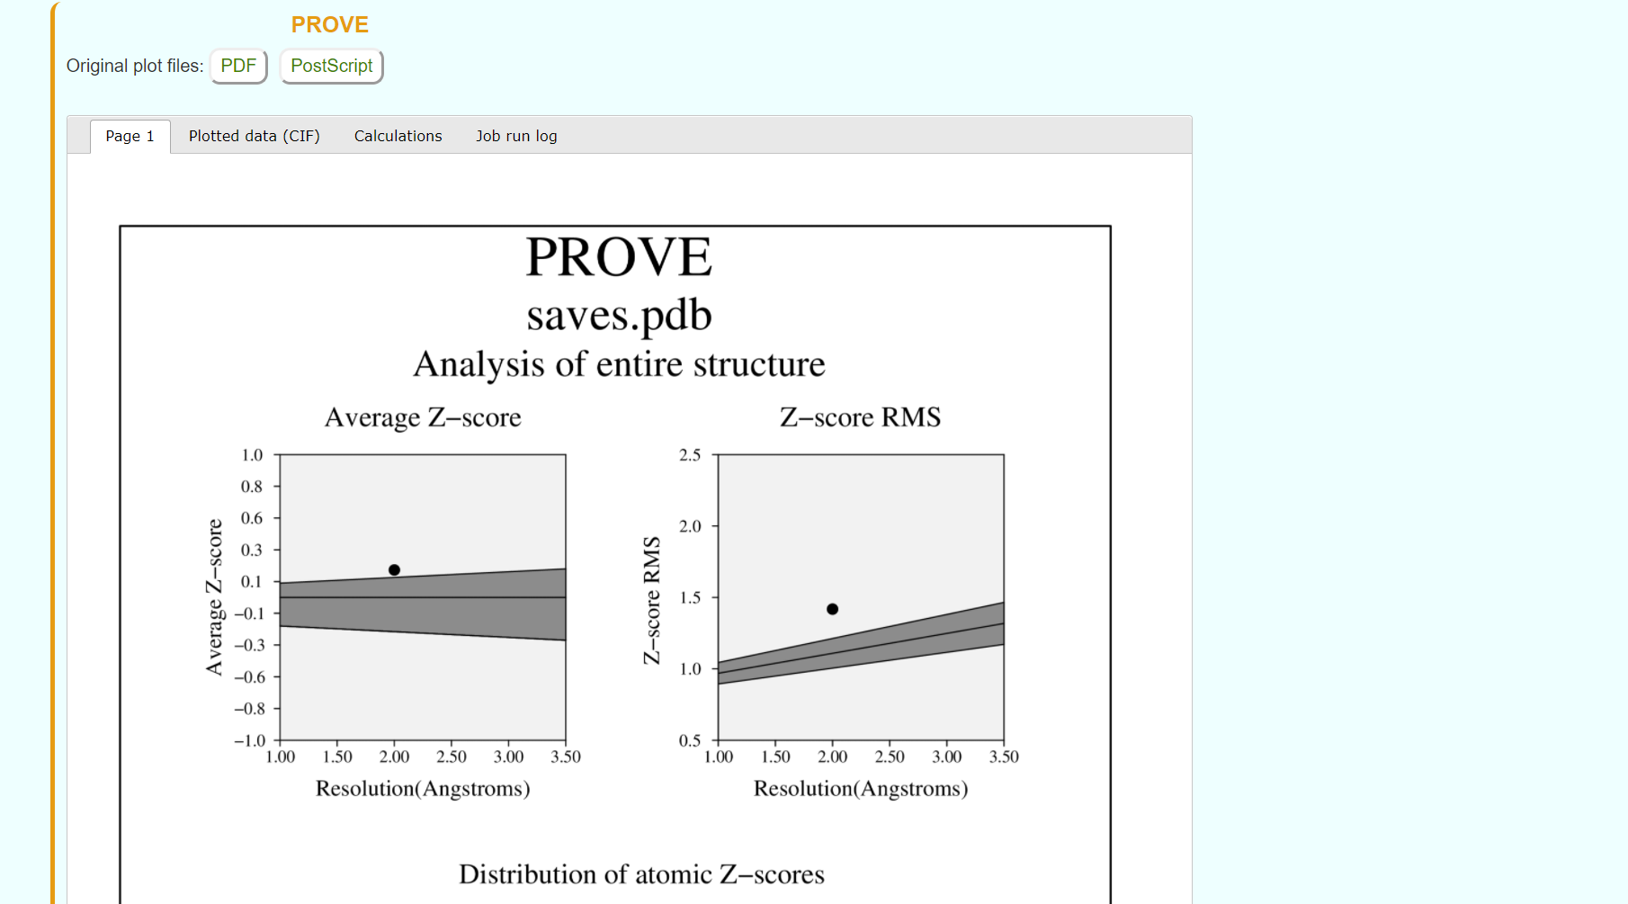**Fig6. Result page for PROVE**

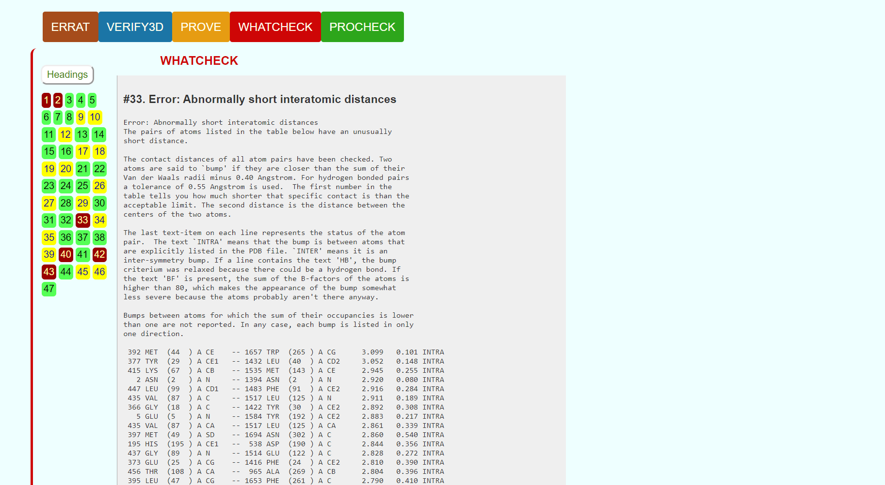**Fig7. Result page for Whatcheck**

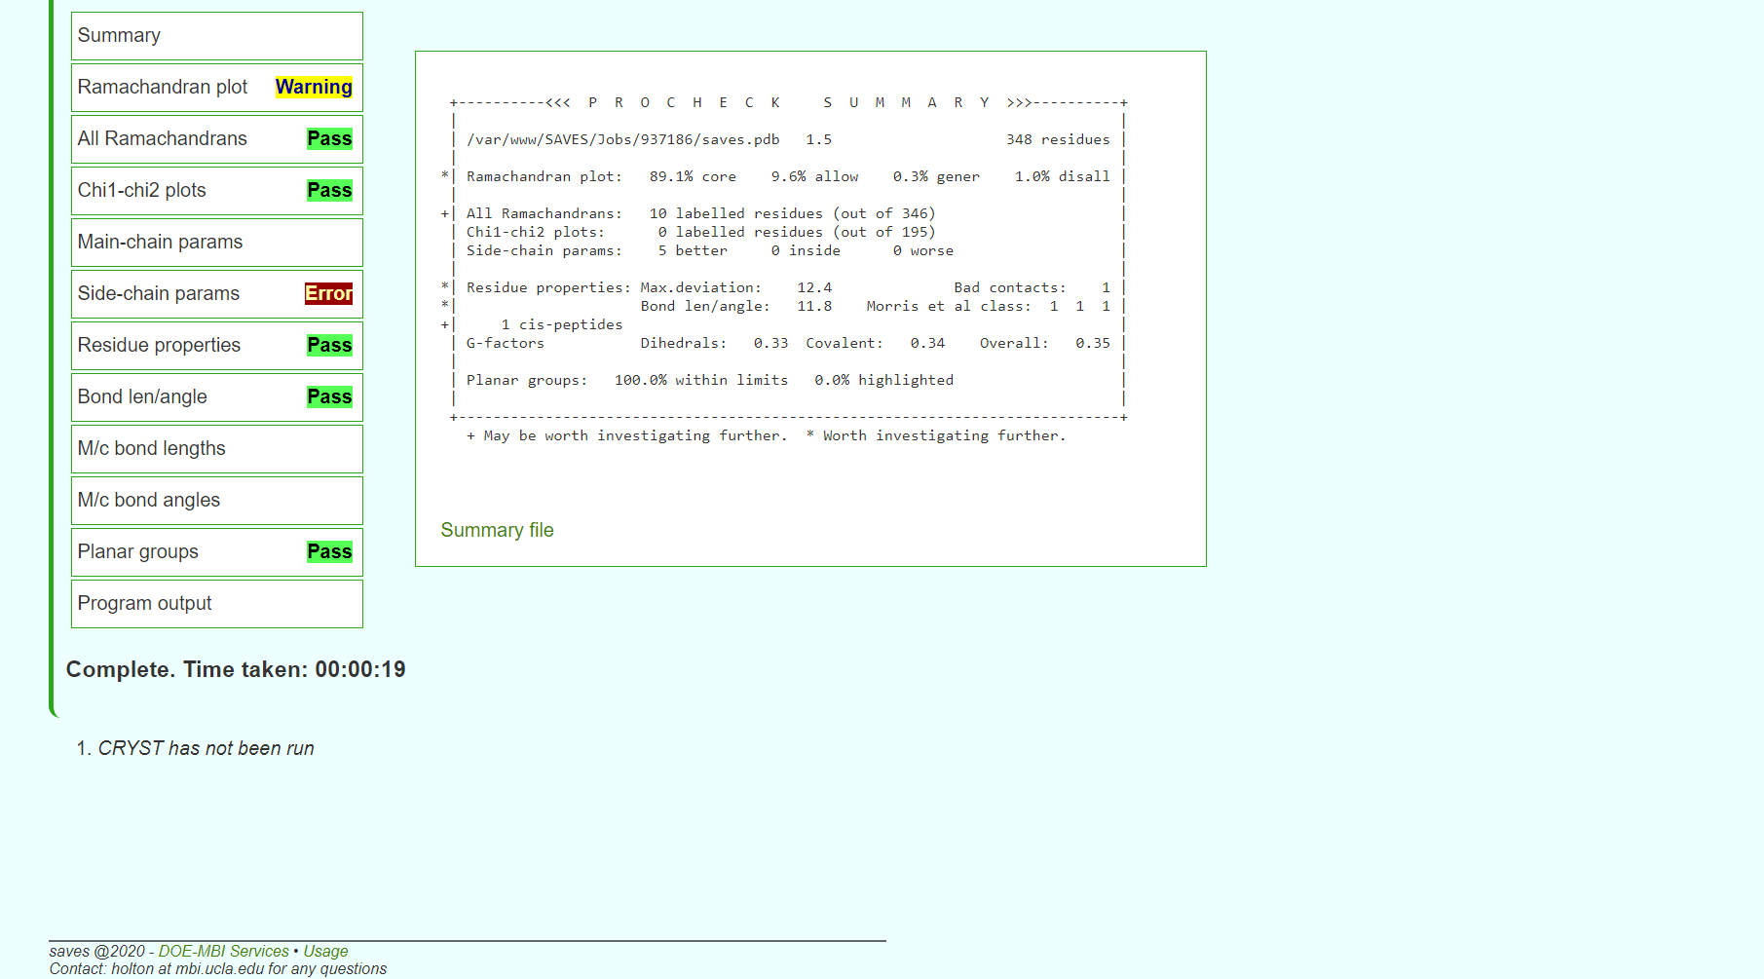**Fig8. Result page for Procheck**

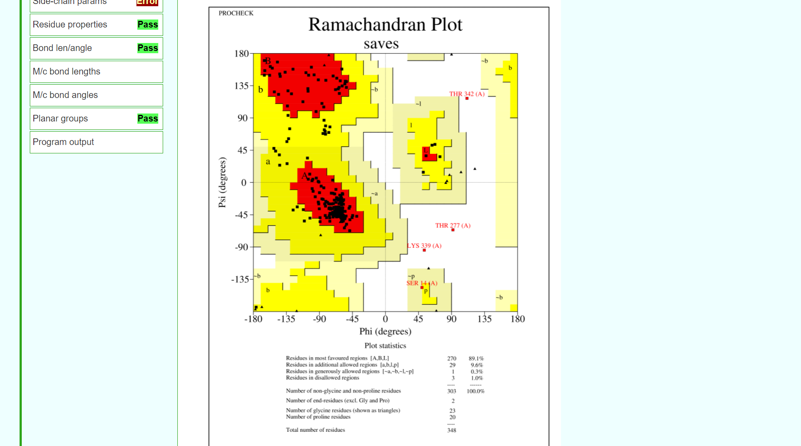**Fig9. Result page for Ramachandran plot**

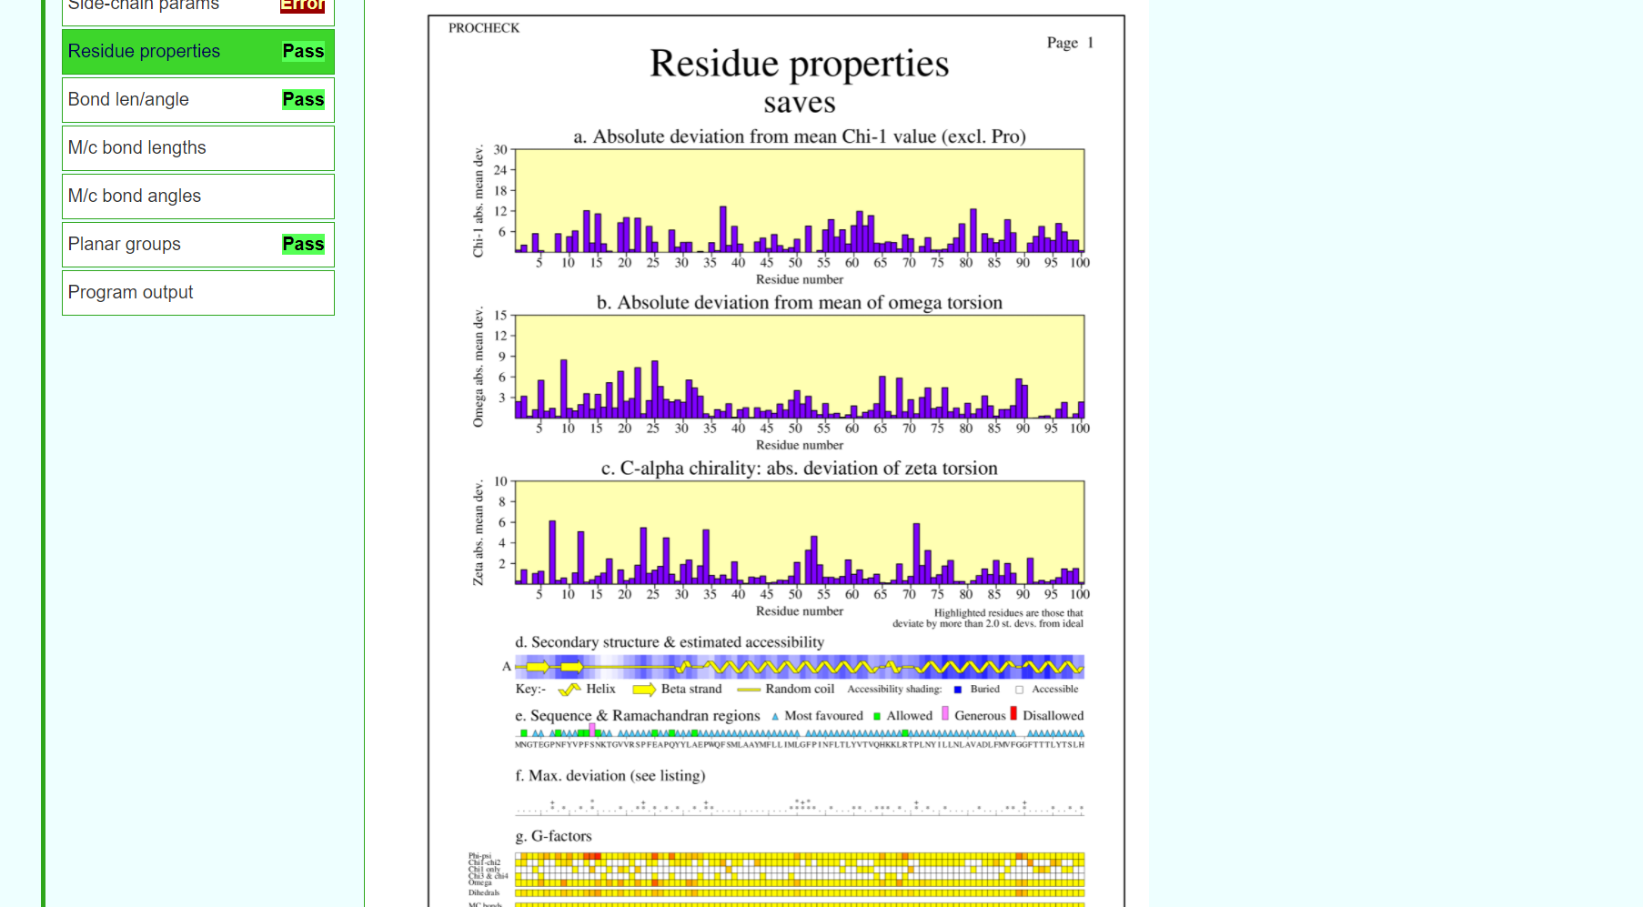**Fig10. Result page for residue properties**

**RESULT:**

The structure predicted for enzyme kinase by abi-initio approach using Robetta was validated using SAVES server.

**CONCLUSION:**

SAVES in an integrated server containing various tools on a single platform that can be used for tertiary structure validation. The predicted structure for Rhodopsin by Robetta passed maximum requirements of validation. Hence, it can be concluded that the structure predicting by Robetta was the most accurate out of all three methods used for prediction.

**REFERENCES:**

1. Xiong, J. (2008).Tertiary structure prediction. Essential bioinformatics. Cambridge: Cambridge University Press. 220-222.
2. SAVESv6.0 - Structure Validation Server. (n.d.). Saves.mbi.ucla.edu. Retrieved March 8, 2022, from <https://saves.mbi.ucla.edu/>
3. SAVESv6.0 - Structure Validation Server. (n.d.). Saves.mbi.ucla.edu. Retrieved March 8, 2022, from <https://saves.mbi.ucla.edu/?job=928054>